Coursework 3 Figures

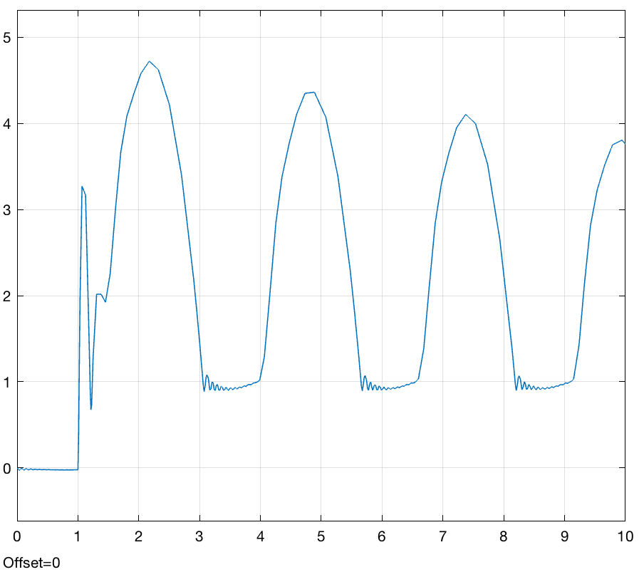

Figure 1: Wheel Displacement

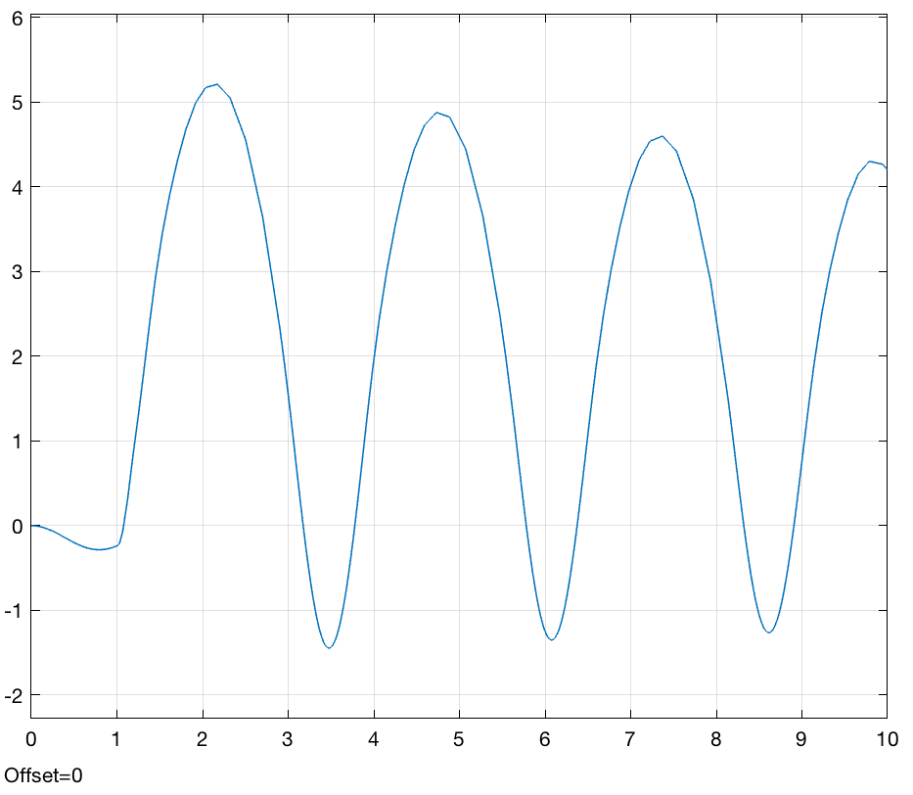

Figure 2: Body Displacement

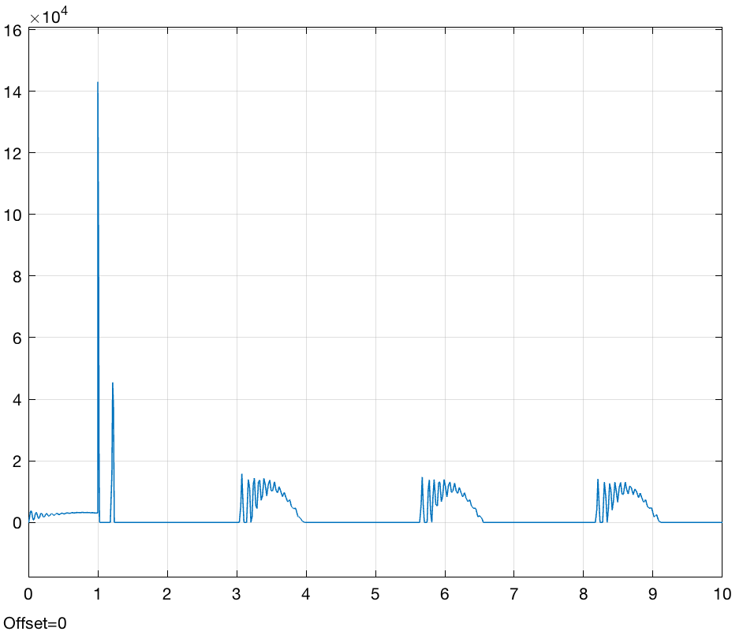

Figure 3: Tyre Force

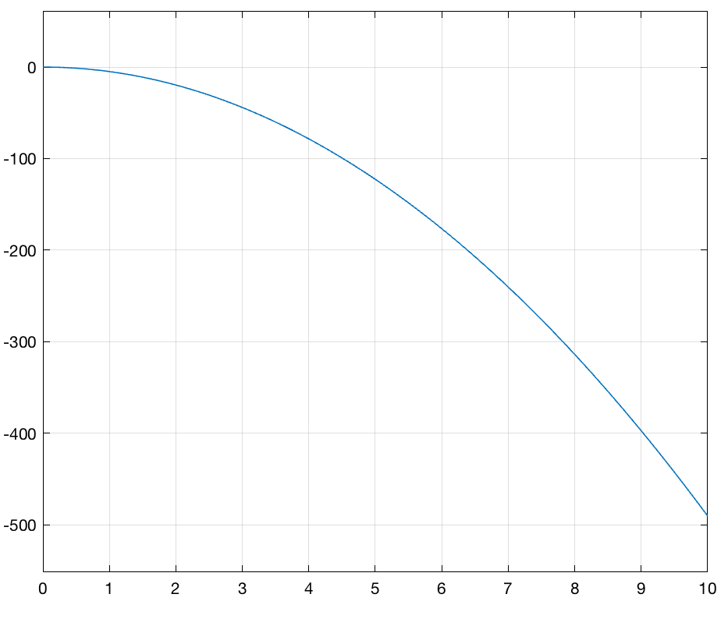

Figure 4: verifying body model: zero force input

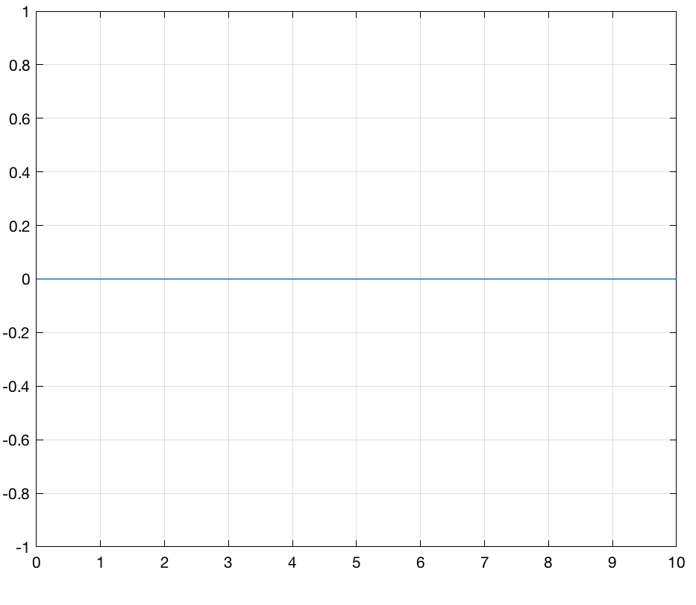

Figure 5: verifying body, force is equal and opposite to body weight

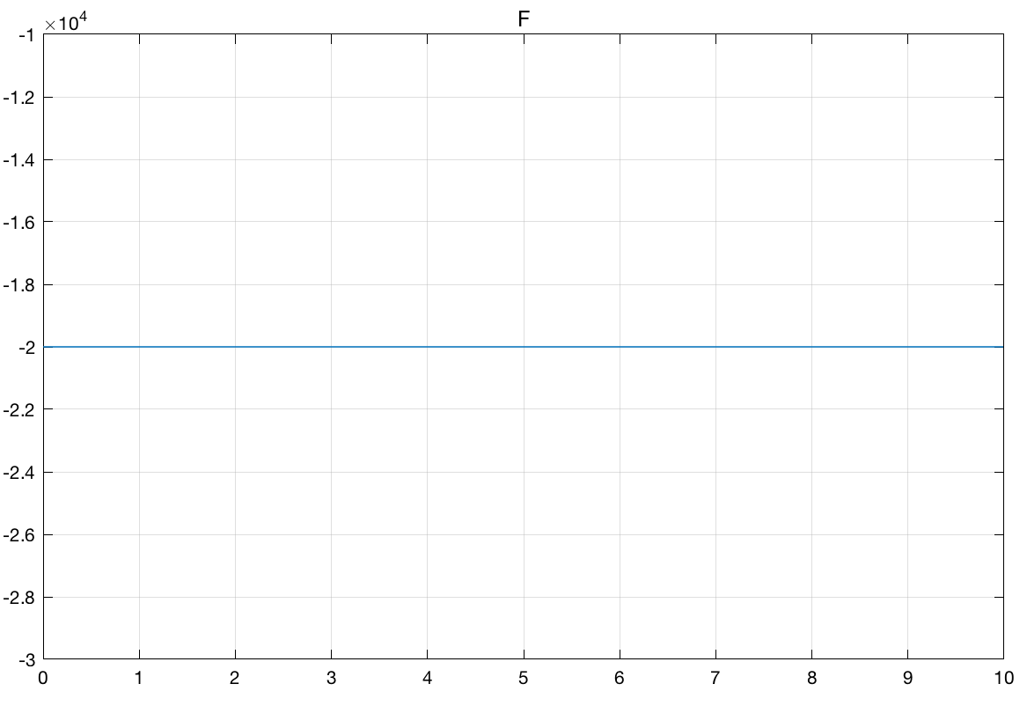

Figure 6: verifying suspension model: unit input in s1; all else 0

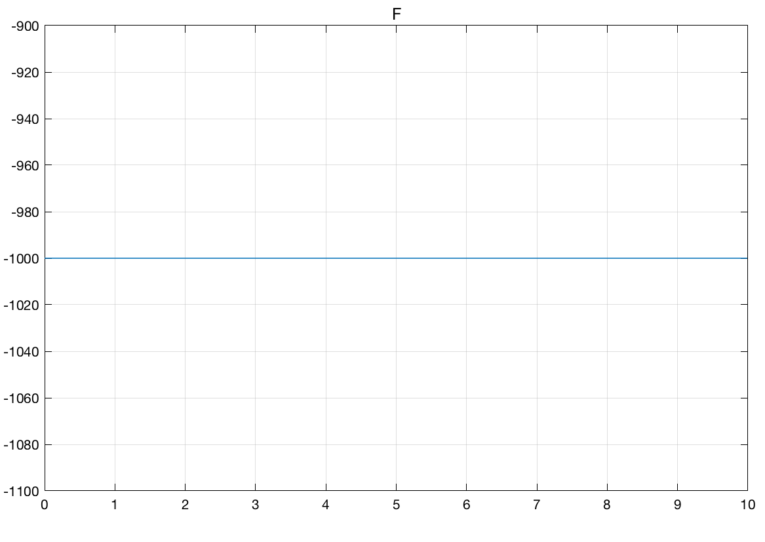

Figure 7: verifying suspension model: unit input in s1d; all else 0

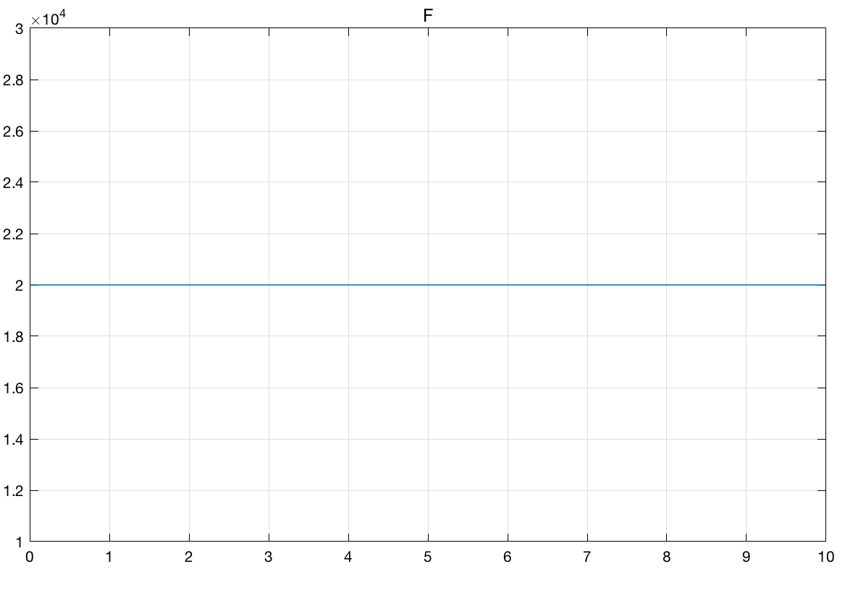

Figure 8: verifying suspension model: unit input in s2; all else 0

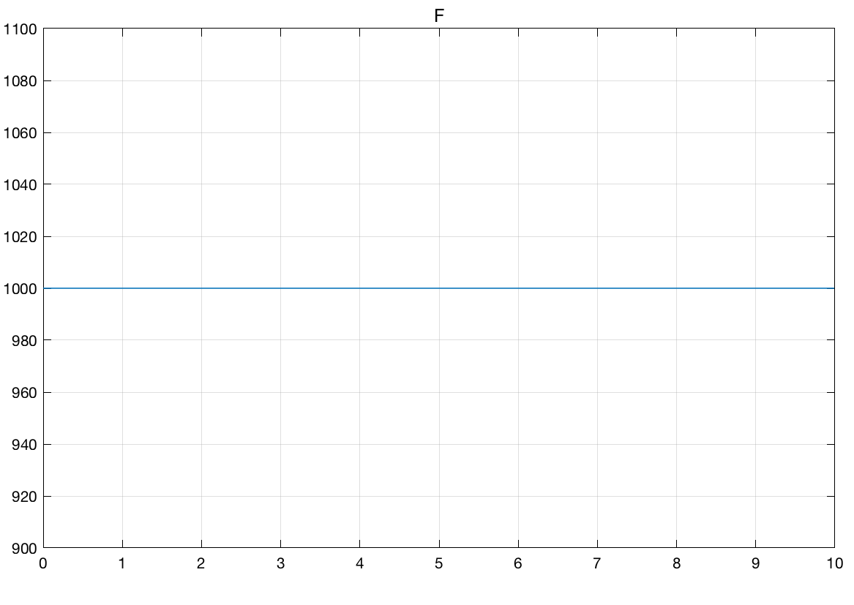

Figure 9: verifying suspension model: unit input in s2d; all else 0

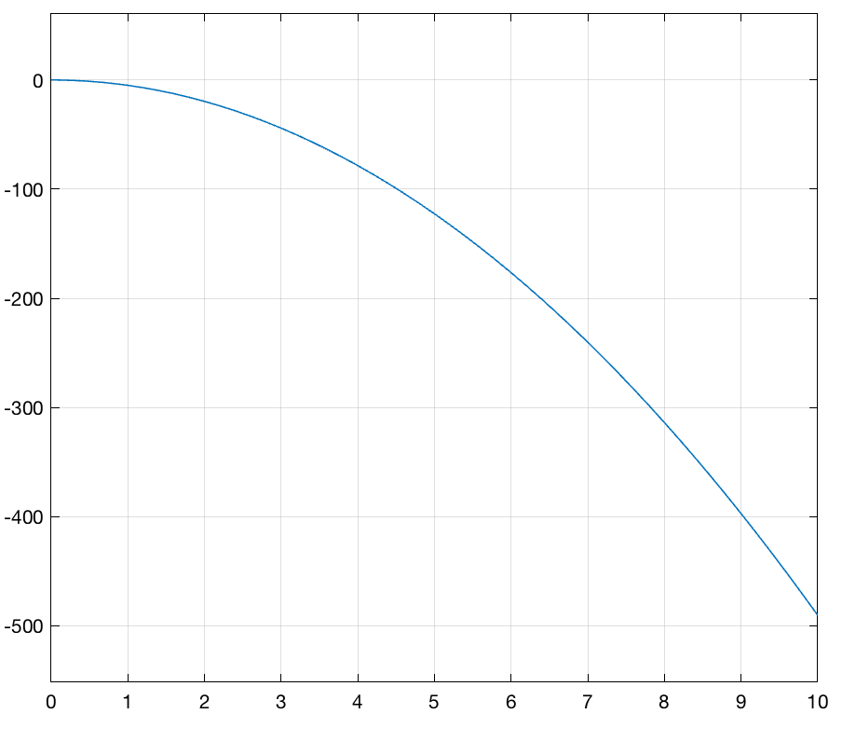

Figure 10: verifying wheel subsystem; kt = 0; F = 0

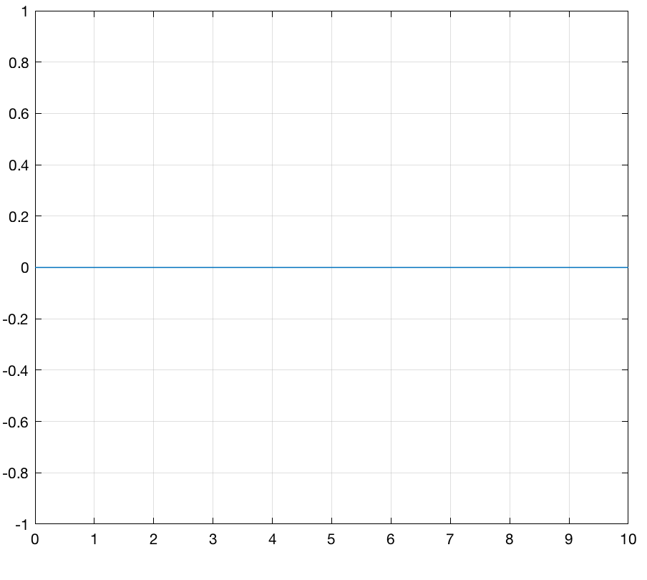

Figure 11: verifying wheel subsystem; kt = 0; F = -g\*m2

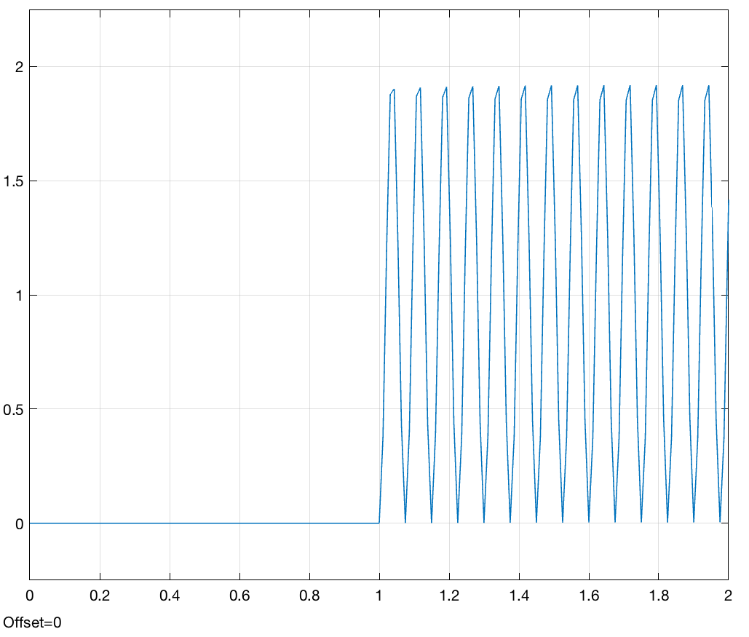

Figure 12: verifying wheel subsystem; kt = 14e4; g = 0; F = 0 (wheel displacement)

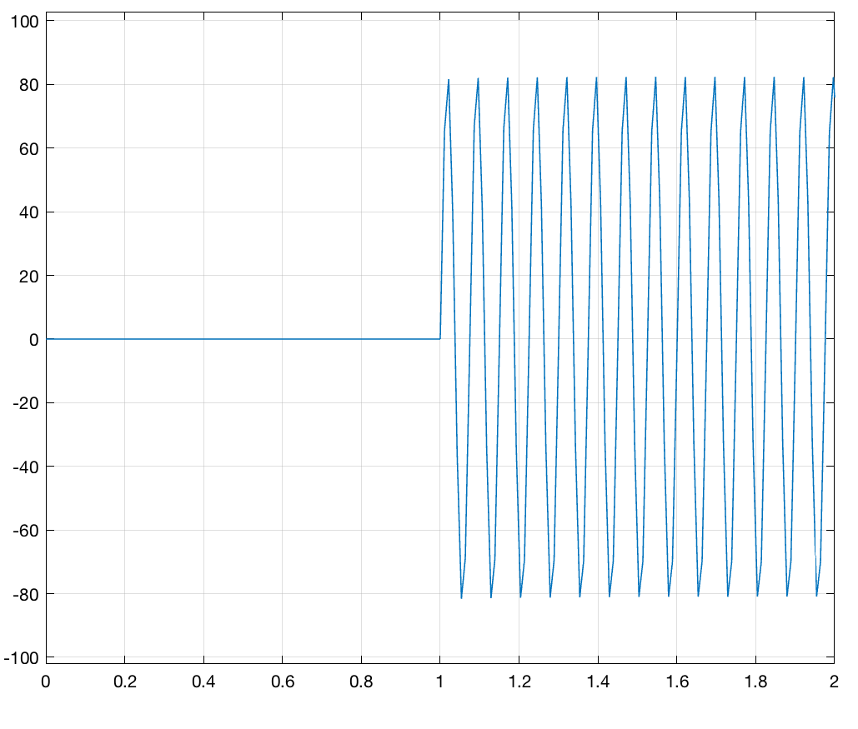

Figure 13: verifying wheel subsystem; kt = 14e4; g = 0; F = 0 (wheel velocity)

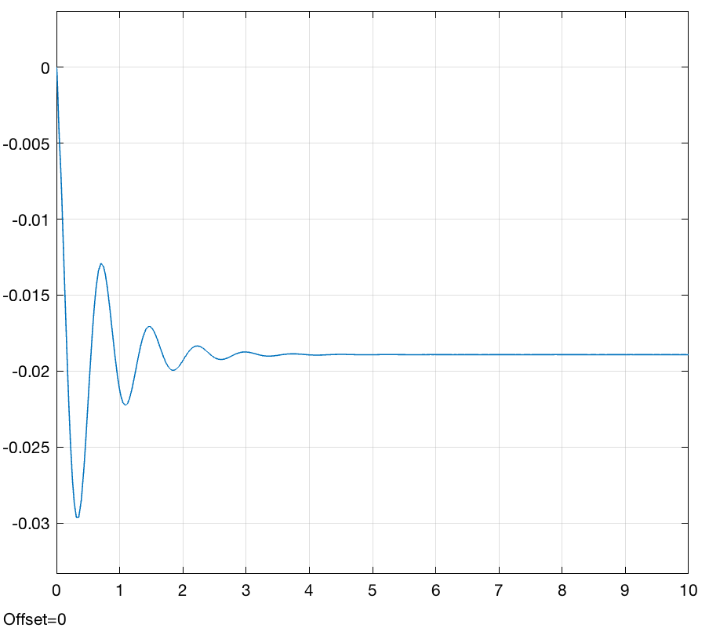

Figure 14: verifying whole system; r = 0; s2 (wheel displacement)

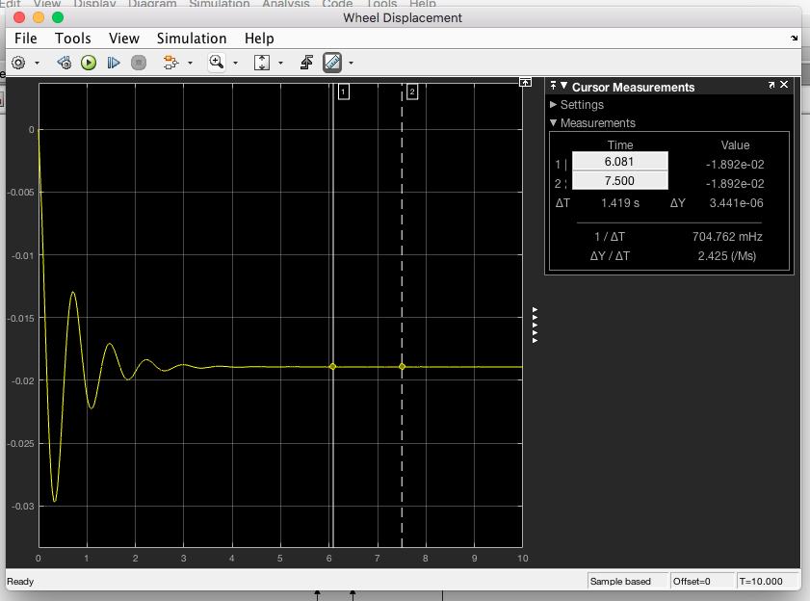

Figure 15: wheel displacement settling

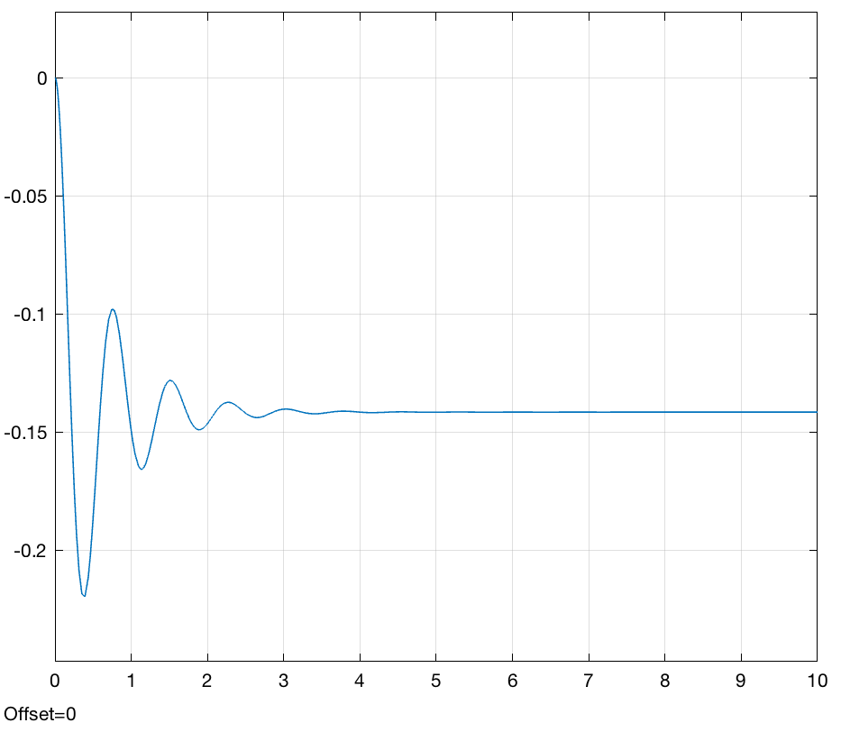

Figure 16: verifying whole system; r = 0 (s1, body displacement)

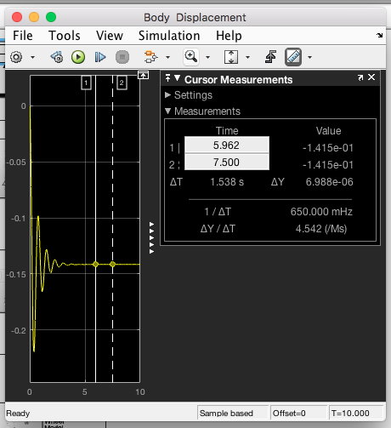

Figure 17: body displacement settling

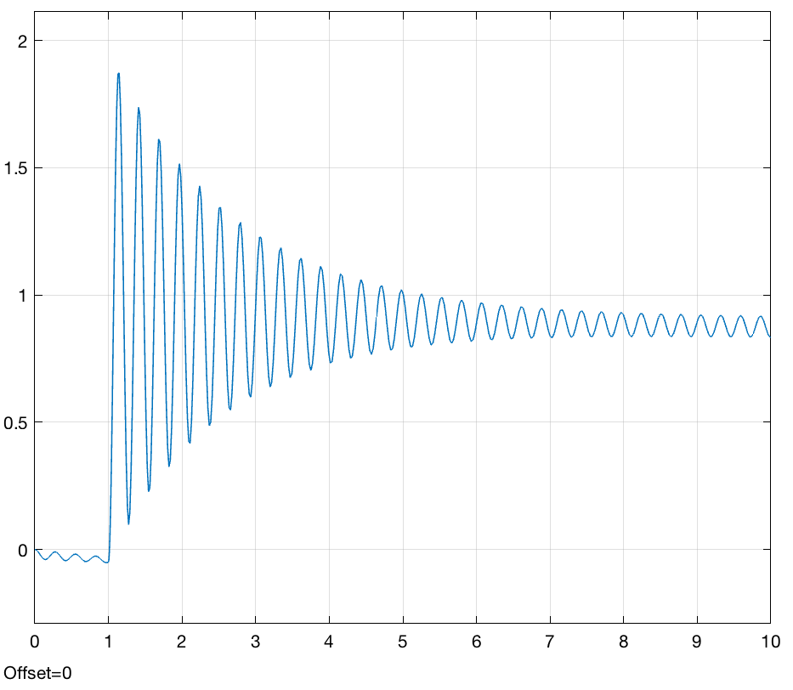

Figure 18: body disp for test b; cs = 100000

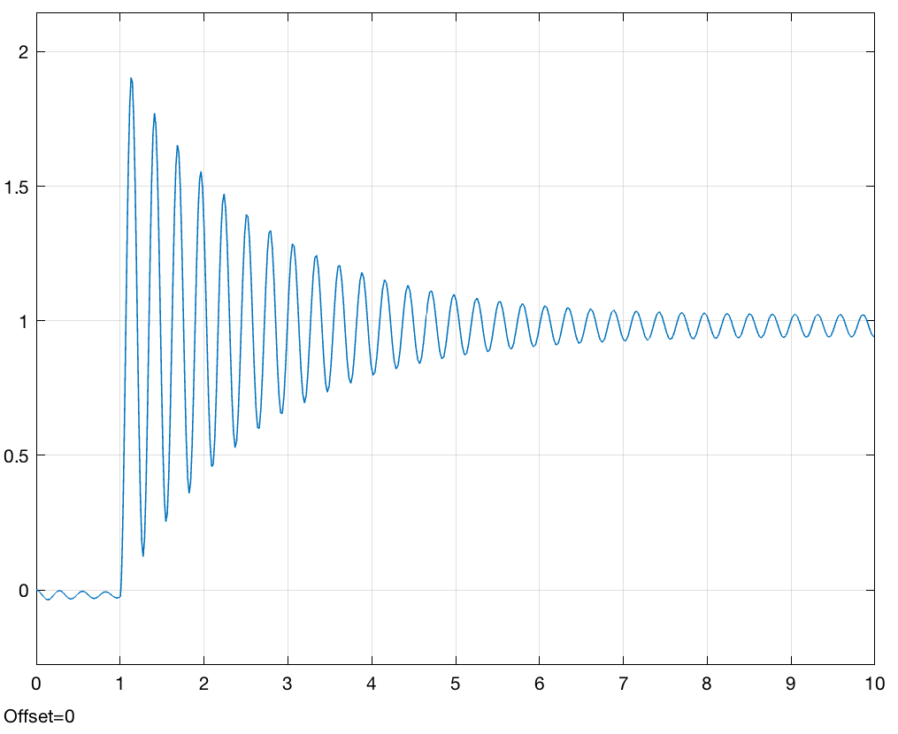

Figure 19: wheel disp for test b; cs = 100000

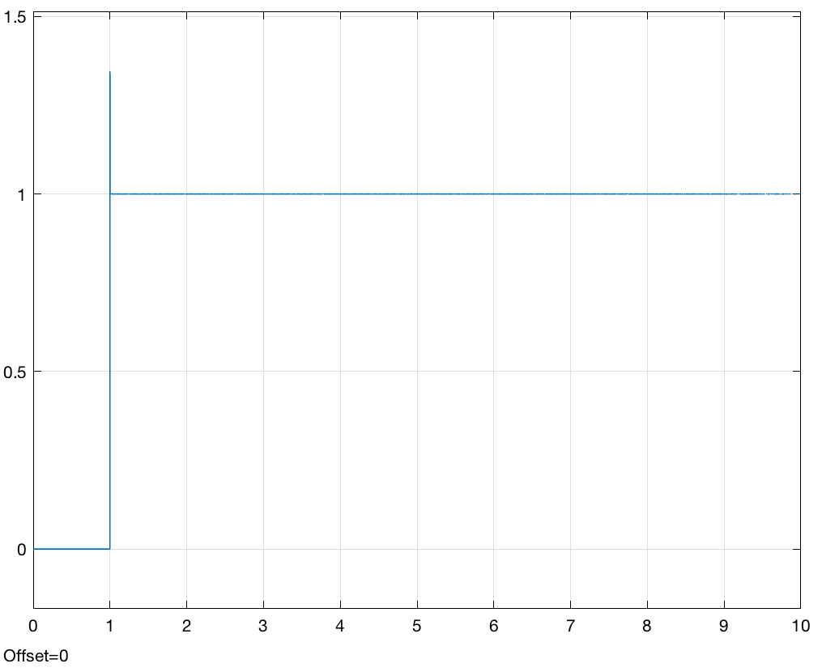

Figure 20: verifying whole system; wheel disp for test c; m2 = 0.002; kt = 14e8

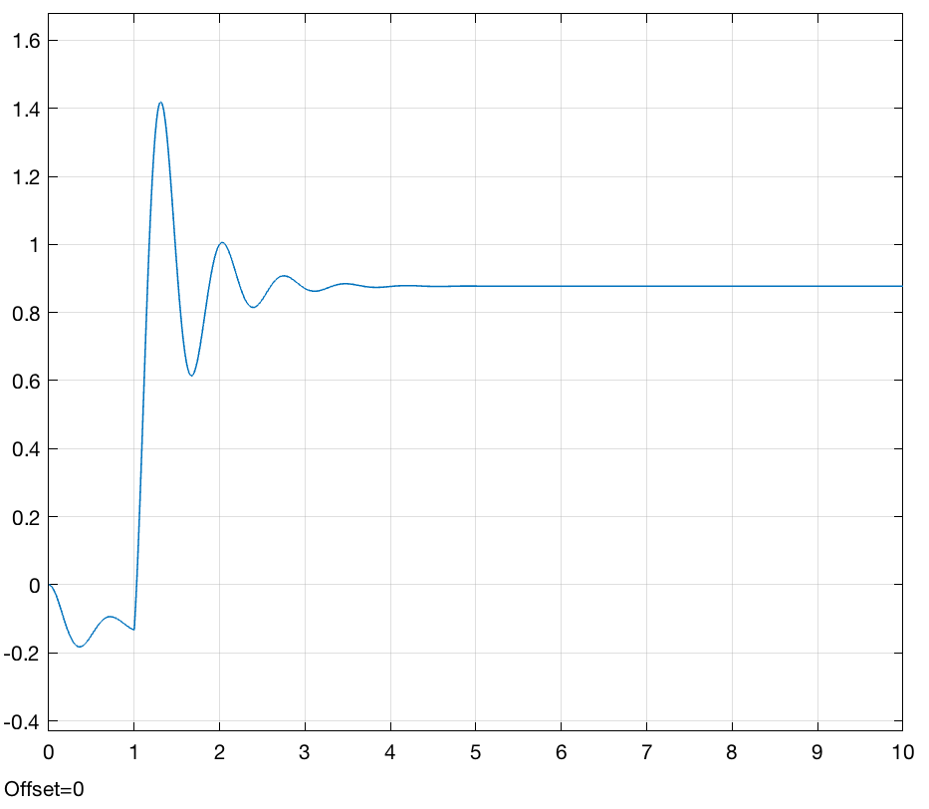

Figure 21: verifying whole system; body disp for test c; m2 = 0.002; kt = 14e8